**DATA @ ANZ**

Task 1: Exploratory Data Analysis

# Point of Analysis

1. Age of customer and transaction volume
2. Weekly, Daily & Hourly Analysis
3. Transaction volume based on Gender, top customers and location
4. Location based Analysis of POS

# Insights

1. Transaction volume decreases significantly for Age > 40
2. Transaction in form of Phone bank are minute and the company can focus on increasing phone banking support as people would want everything on mobile phones in near future.
3. Credit is only in the form of Salary/pay which is a check on credibility of data as we don’t see any anomalies in movement of data.
4. Hourly analysis show that the transaction peak time is around noon and is low between 1AM-4AM.
5. Weekly analysis confirms that POS sales rise on weekends and Salary is credited between Monday and Friday i.e. the bank working days. Also, average amount transacted each week as marginalized difference and both male and female customers have mostly similar average values.
6. Transaction volume clearly shows that most of the transactions are POS & Sales-POS i.e. the customers tend to pay a lot at merchant points directly as compared to transfers or payments.
7. Transaction volume has negligible difference based on gender which implies that the bank has an unbiased service towards gender, and customers from both genders trust the bank.
8. The transaction volume is pretty low in suburbs other than Melbourne and Sydney the reason might be low customer ratio which can be looked ahead by the marketing team.
9. Merchants are very well spread across the country.
10. Location based analysis of customers show that customer has transacted from different states with in this period and density of transaction volume is towards New South Wales and Queensland.

Below are my findings in the form of graphs

## Age vs Transaction

Age 18 to 25 Age 25 to 40

Transaction Type Transaction Type

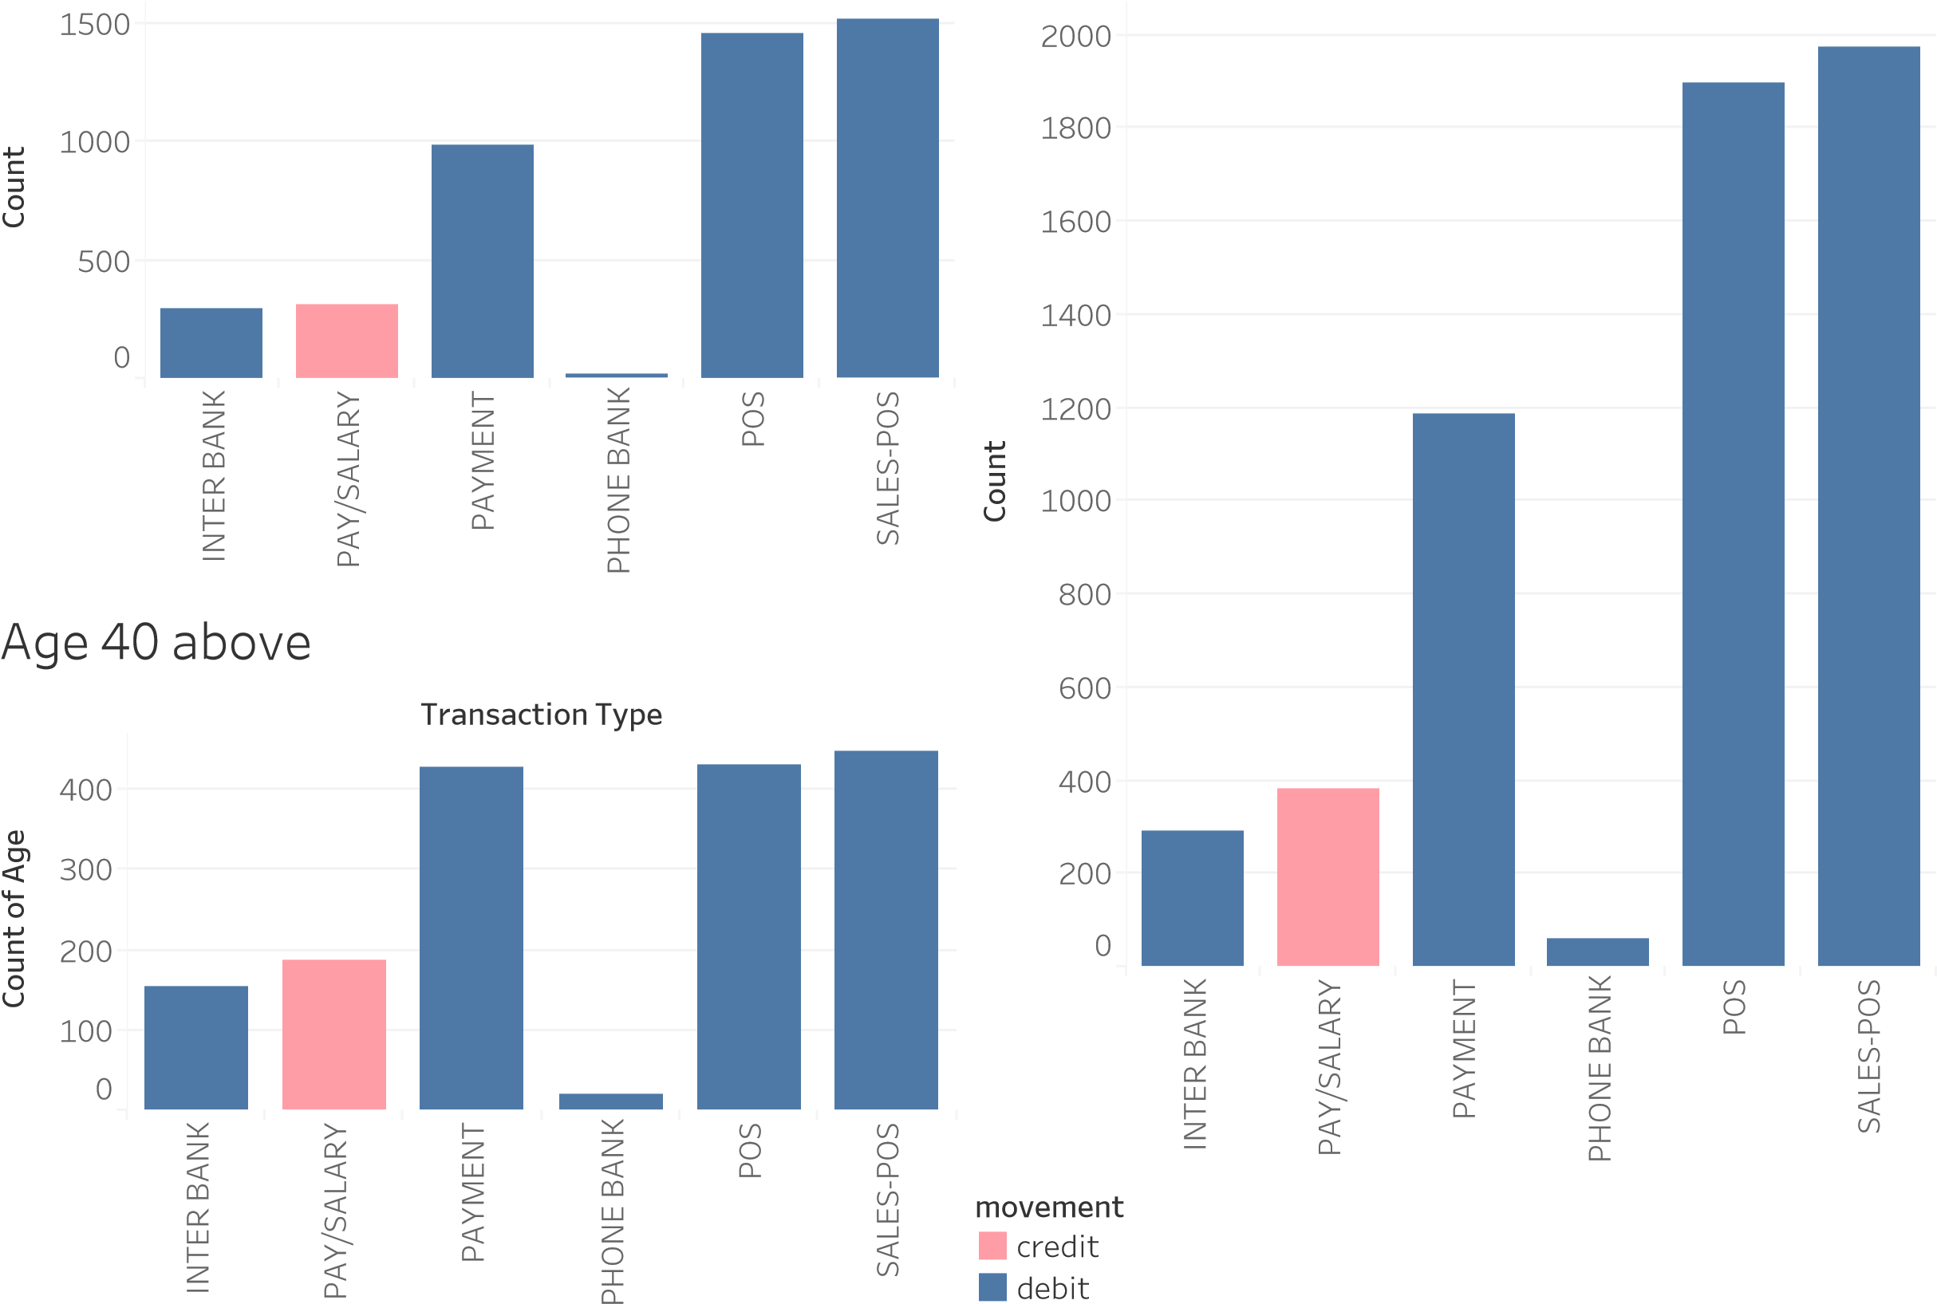

## Location based Analysis

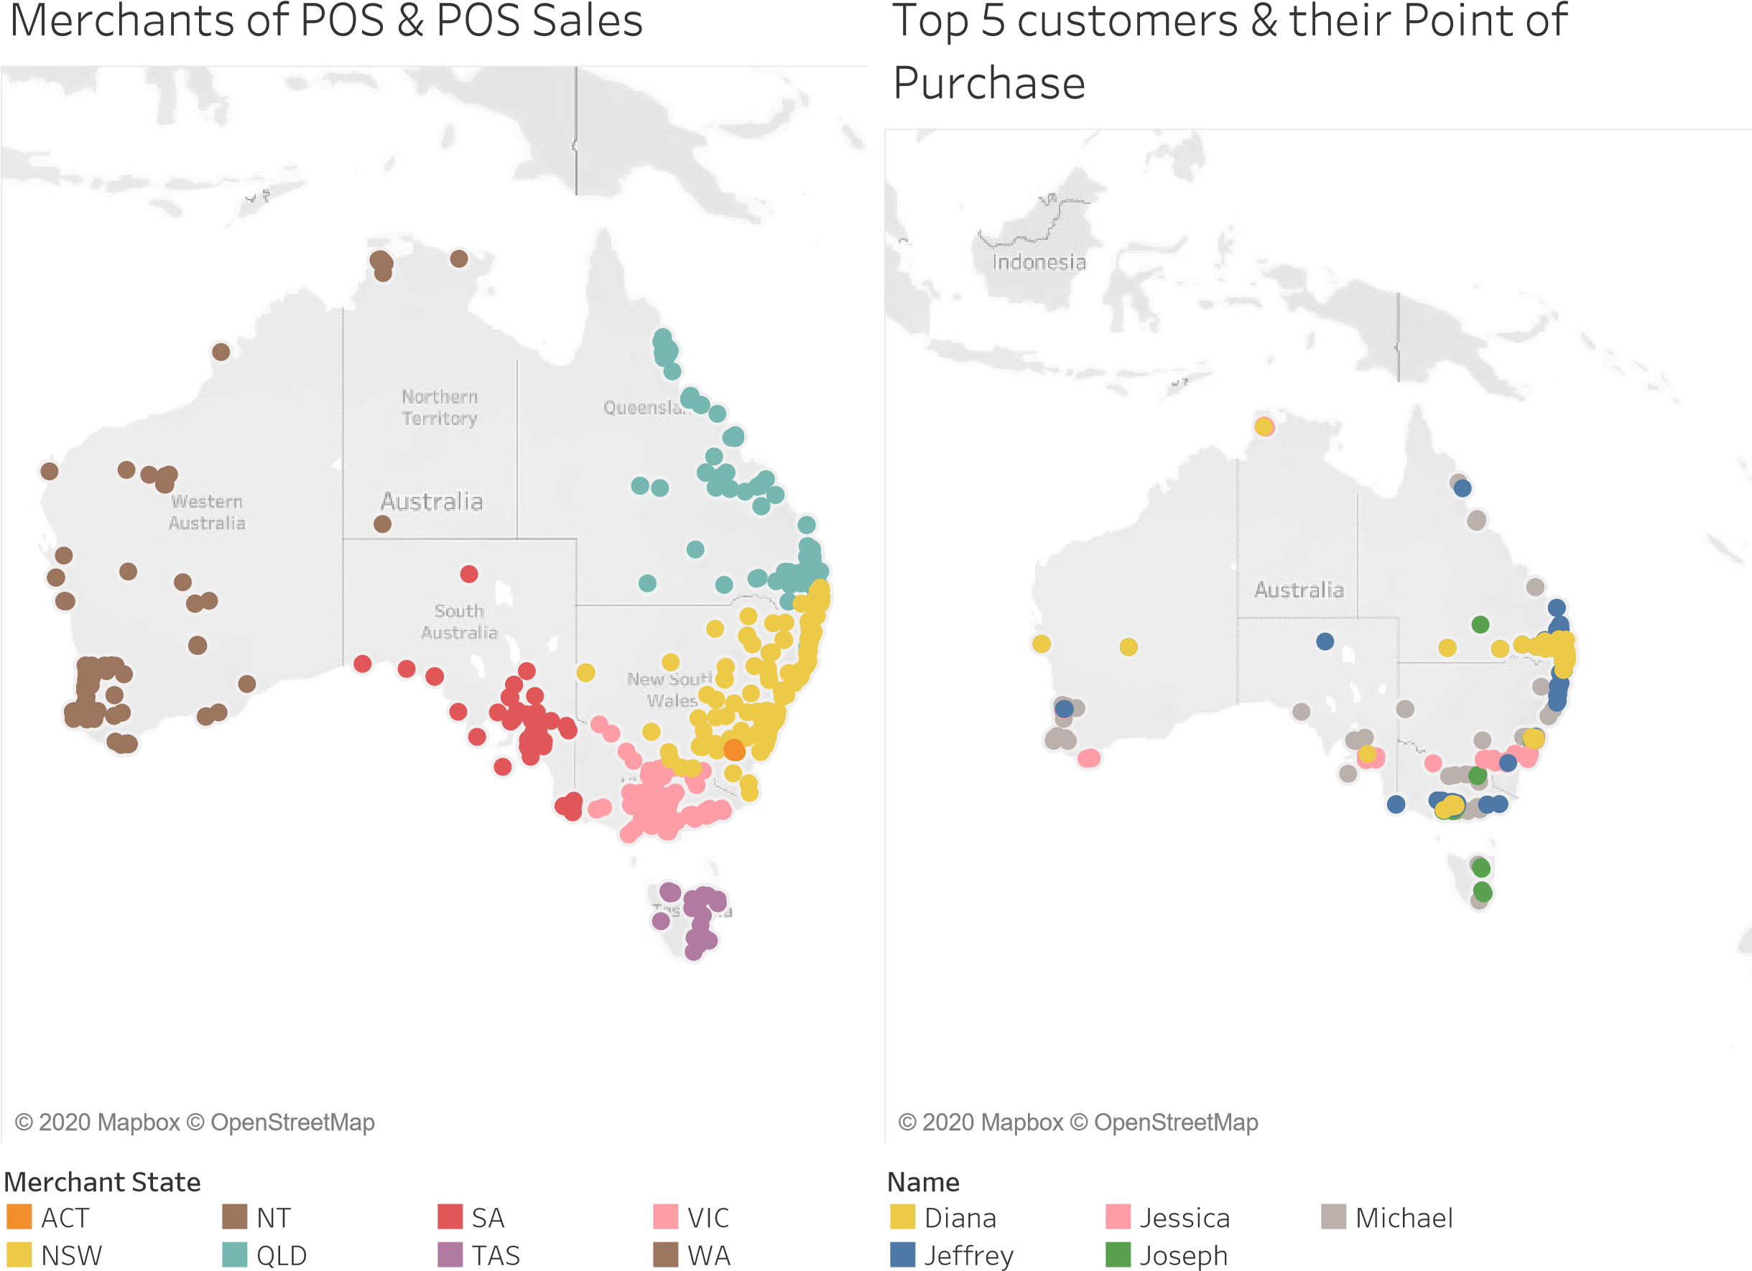

## Customer & Transaction based Analysis

Gender Count Transactions as per State Transaction TypeINTER BANK

F

M

0

K

2

K

K

4

6

K

C

o

u

n

t

o

f

g

e

n

d

e

r

Merchant State

W

A

V

I

C

T

A

S

S

A

Q

L

D

N

T

N

S

W

A

C

T

0

500

1000

1500

2000

C

o

u

n

t

o

f

T

r

a

n

s

a

c

t

i

o

n

PAYMENT

PHONE BANK

POS

SALES-POS

gender PAY/SALARY

Top 10 customers Suburbs with more than 40

Name Transactions

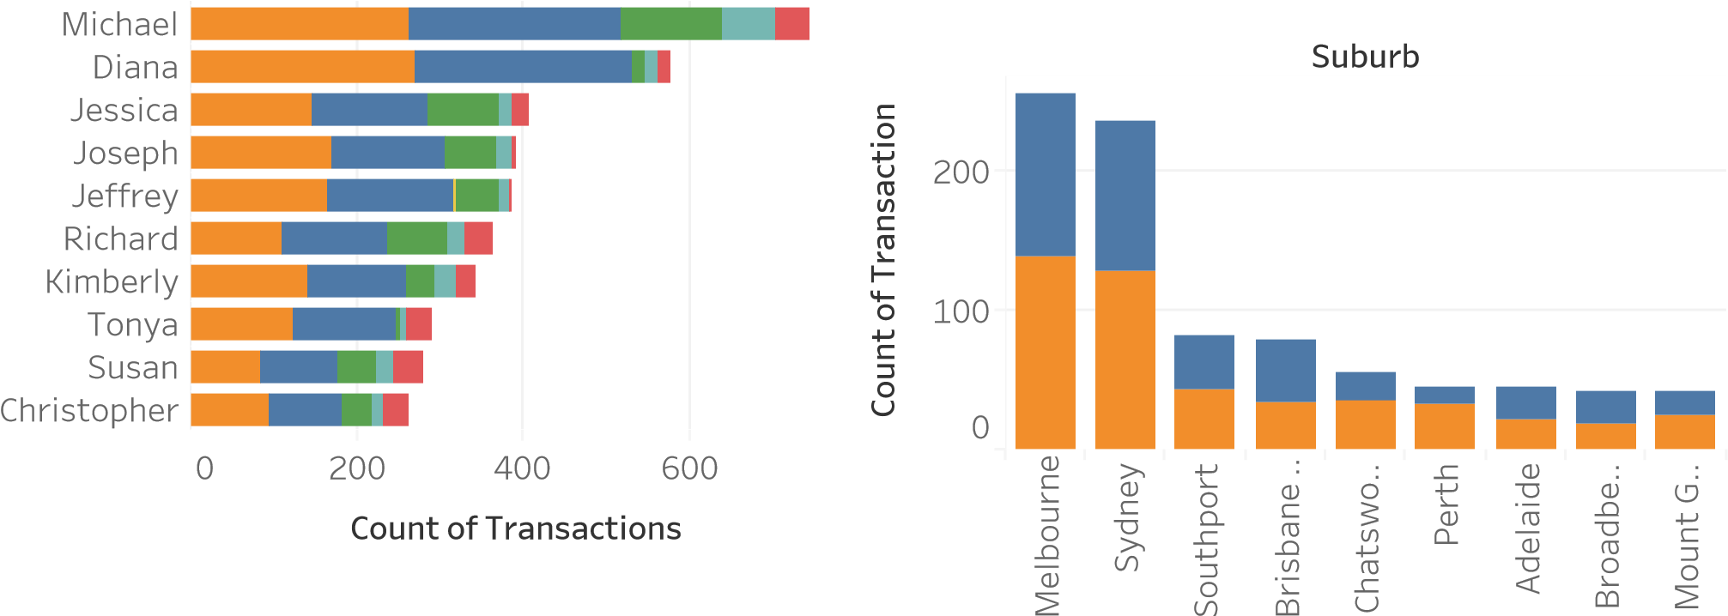

## Weekly, Daily and Hourly Analysis

Hour of Transaction vs Count Average amount transacted weekly

Hour of Transaction Week

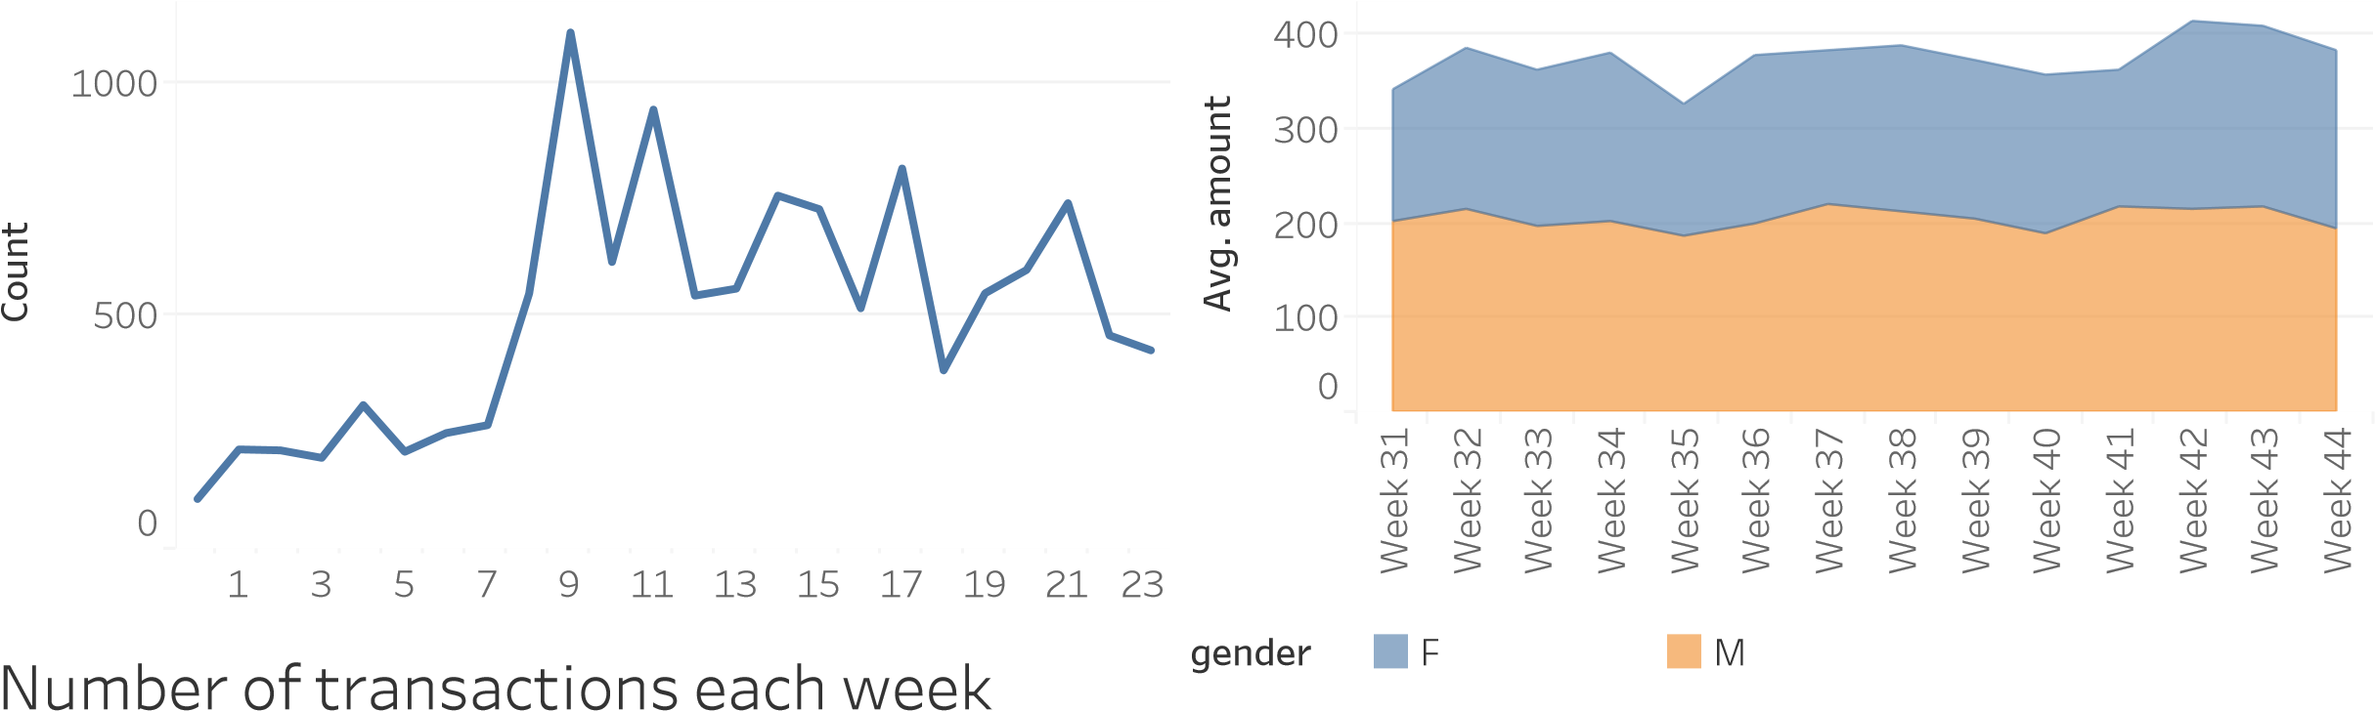

Week Day-wise Transaction Analysis

